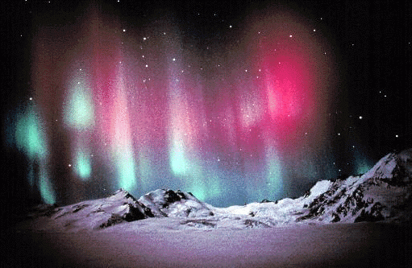
Apostrophe of Possession
Earth’s Magnetic Field

Apostrophe of possession is used to show that the object belongs to someone or something. For example: Tom’s bicycle. The bicycle belongs to Tom. Or, the house’s roof needed repairing. The roof belongs to the house.

Choose the correct alternative:

1. The Earth’s/Earths magnetic field runs from north to south.

2. The Earth behaves as though it has a huge bar magnet at its/it’s centre.

3. Scientists/scientist’s believe the Earths/Earth’s magnetic field is generated by moving molten rock inside the Earths/Earth’s core.

4. The Earths/Earth’s magnetic field directs our compasses/compass’s.

5. The Sun produces solar winds. These are high-energy particles/particle’s that can damage living things.

6. The Earths/Earth’s magnetic field and the atmosphere slows these charged particles/particle’s down as they travel towards the Earth.

7. It directs their path towards the magnetic poles/pole’s.

8. Collisions between these particles/particle’s and those in the upper atmosphere can produce spectacular light shows/show’s called auroras.

Questions:

1. Which direction does the Earth’s magnetic field run? _____________________

________________________________________________________________

2. What do scientists believe generated the Earth’s magnetic field? ____________

________________________________________________________________

3. What instrument does the Earth’s magnetic field direct? ___________________

________________________________________________________________

4. What are solar winds? ______________________________________________

________________________________________________________________

5. Why are solar winds dangerous? _____________________________________

________________________________________________________________

6. What slows down the charged particles from the Sun? ____________________

________________________________________________________________

7. Explain how an aurora occurs ________________________________________

________________________________________________________________

________________________________________________________________

________________________________________________________________

________________________________________________________________

